This document describes the process of how to download the latest Python script version to check for errors in config files

Don’t have Python?

Create a directory named Python3_7 in the C directory E.G. C:\Python3_7

Go to <https://github.com/corryandrew/ConfigChecks>

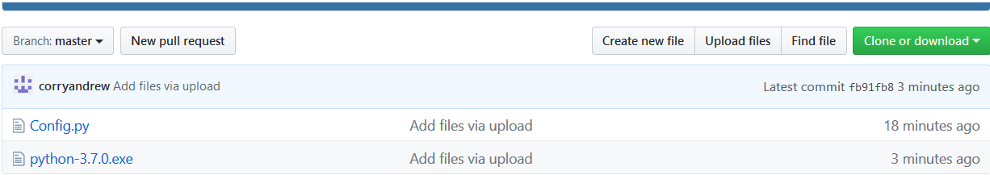

Click “Clone or download”

Click the “download zip” option

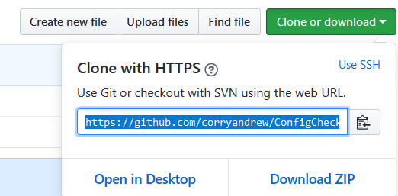

This will download the Python.exe install file as well as the Python Config.py script file.

Once downloaded, double click the .exe.

A screen should pop up like below.

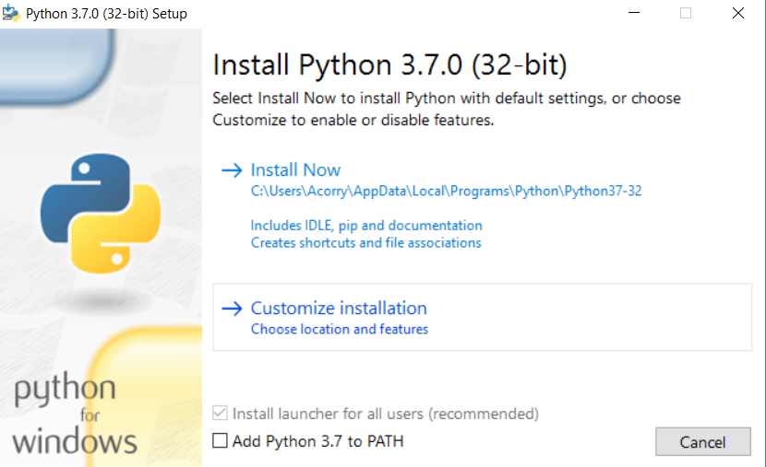

Choose “Customize installation”

Everything should be ticked

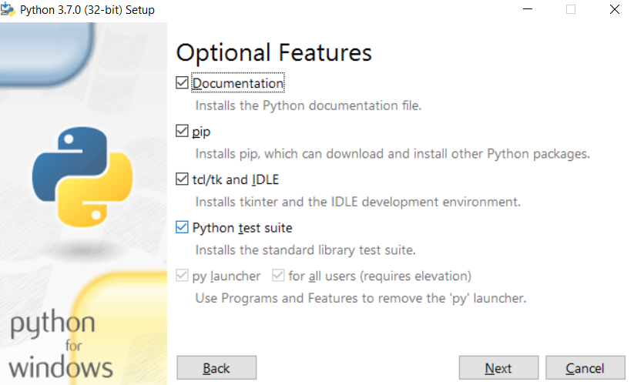

Click “Next”

The 3 boxes should be ticked as per below.

Change the install location to be the new directory in step 1, “C:\Python3_7”

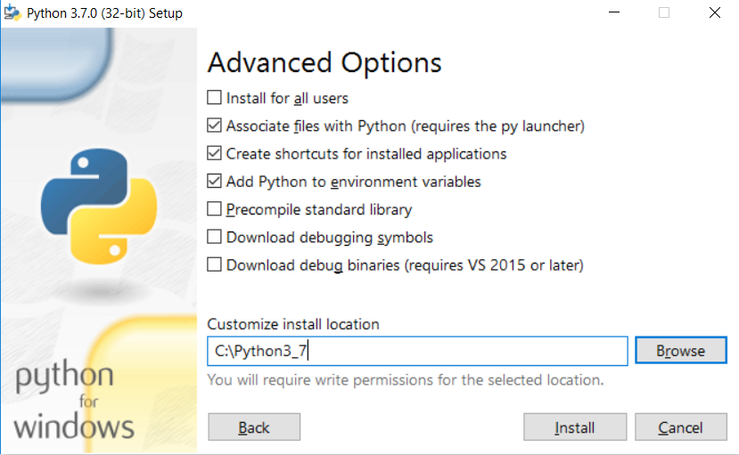

Click “Install”

Installing extra Python software

You now need some Teradata python software installed

Type “cmd” in your windows search bar.

Right click on the command prompt program and click “Run as administrator”

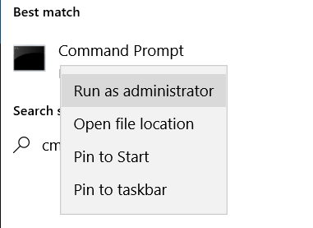

Once the command prompt starts, type “cd C:\Python3_7”, this changes your directory to the new Python3_7 directory

Then type “python -m pip install teradata”, this will install the Teradata software you need.

Type “pip install Reports”

You are now done with downloading and installing Python

Python config script

If you downloaded Python, you will already have the Python config script.

If not, then review above steps on how to download the folder ConfigCheck from Github. This will have the config script you need.

The script must live in “C:\Python3_7\My Scripts\Config Solution”

You need to create a file with your connection details in named “db.cnfg” in “C:\Python3_7\My Scripts\Config Solution”.

The “User” must be your user name, PassWd must be your Vodacom password (not your database password). Authentication is LDAP

An example file has been imbedded, just use NotePad to edit



To run the Python script (this is just 1 way, you can also run the script thru Python itself)

Right click on the command prompt program and click “Run as administrator”



Type “cd C:\Python3_7\My Scripts\Config Solution”

To run the script.

Type Config.py

The script will look for all .CSV files (make sure only the files you want to process are in the directory C:\Python3_7\My Scripts\Config Solution)

It will check if the files have a blank line at the end of the file, it the files does not have a blank line it will be moved to C:\Python3_7\My Scripts\Config Solution\Last_Line

It will check to make sure the number of columns you are trying to insert match the column count from the database/table that you passed in when running the script

It will check to see if there are space and comma issues

It will check for date issues

Errors will be printed on the command screen

E.G.

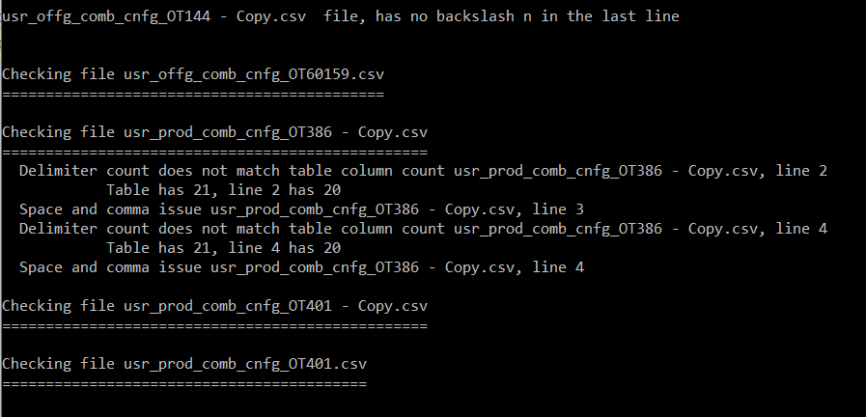

For file “OT144 – Copy.csv”, this file had no blank line at the end of the file

“OT60159” – nothing was wrong

“OT386” – the amount of values trying to be inserted did not match the table column count

“OT401” – nothing wrong

Invalid Date formats

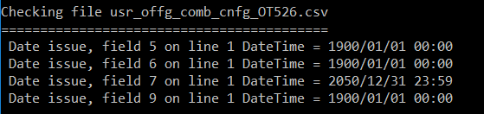

The last bit of printed information shows you which files were processed or not

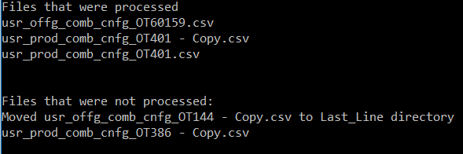

All the files with no errors will be combined in “C:\Python3_7\My Scripts\Config Solution\Final_Files” per config name table